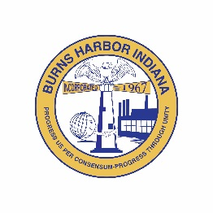
Burns Harbor
STORMWATER BOARD
President  Jack McGraw  Vice President  Allen Migliorini  Board Member  Lisa Draves  Secretary  Madeline Parker    Town of Burns Harbor  Stormwater Board  1240 North Boo Road  Burns Harbor, IN 46304  P 219.787.1165  F 219.787.1353  www.burnsharbor-in.gov | MEETING AGENDA  Wednesday, June 18, at 6:30 p.m.  Call to Order  Roll Call  Approval of Minutes  - April 16, 2024  Correspondence  Engineer Report  Old Business  - Future Infrastructure Projects  - MS4 Compliance  New Business  - Financial Report  - Approval of Claims with two (2) or more signatures  Good of the Order of the Community & Any Other Business  Announcements  Adjournment  Next Meeting: August 13, 2024  The Town of Burns Harbor is committed to providing access, equal opportunity and reasonable accommodation in its services, programs, and activities for individuals with disabilities. To request accommodation, contact the Town of Burns Harbor at (219) 787-9413.
  ZOOM MEETING INFORMATION
  Meeting ID: 828 3781 5948
  Passcode: 309210
  Dial in: (312) 626-6799

