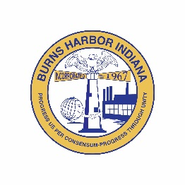
Burns Harbor
STORMWATER BOARD
President  Jack McGraw  Council President  Term ends12/31/2025  Vice President  Open Position  Board Member  Lisa Draves  Council Appointment  Term ends12/31/2025  Recording Secretary  Madeline Parker    Town of Burns Harbor  Stormwater Board  1240 North Boo Road  Burns Harbor, IN 46304  P 219.787.1165  F 219.787.1353  www.burnsharbor-in.gov | MEETING NOTICE:  The August 20, 2025  STORMWATER BOARD meeting has been canceled.  No current business.

