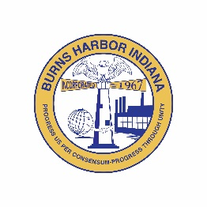
Burns Harbor
STORMWATER BOARD
President  Jack McGraw  Vice President  Open Position  Board Member  Lisa Draves  Council Appointment  Term ends12/31/2025  Gordon McCormick  Council Appointment  9/10/2025-12/31/2026  Secretary  Gina Bondi    Town of Burns Harbor  Stormwater Board  1240 North Boo Road  Burns Harbor, IN 46304  P 219.787.1165  F 219.787.1353  www.burnsharbor-in.gov | MEETING AGENDA  Wednesday, December 17, at 6:30 p.m.  Call to Order  Roll Call  Approval of Minutes  - October 15, 2025  Correspondence  Engineer Report  Old Business  - MS4 Compliance  New Business  - Financial Report  - Approval of Claims with two (2) or more signatures  Good of the Order of the Community & Any Other Business  Announcements  Adjournment  Next Meeting: February 18, 2025  The Town of Burns Harbor is committed to providing access, equal opportunity and reasonable accommodation in its services, programs, and activities for individuals with disabilities. To request accommodation, contact the Town of Burns Harbor at (219) 787-9413.
  ZOOM MEETING INFORMATION
  Meeting ID: 832 9356 3821
  Passcode: 234392
  Dial in: (312) 626-6799

